Personalized E-learning Course Recommendation system
In this project as per your requirement we have used University Name, ratings and difficulty level to make course recommendation. We are displaying top 10 most similarity scores courses as Recommendation. While recommending we are displaying course name, skills, course description and course URL.
To implement this project we have designed following modules
- New User Sign up: using this module user can sign up with the application
- User Login: using this module user can login to system
- Get Course Recommendation: using this module use can choose desired university, difficulty and ratings and then system will apply NLP algorithm to select top similarity matching score courses as recommendation.
To run project install MYSQL console and given password as root and then copy content from database.txt file and paste in MYSQL console to create database
Install python3.7.2 and then copy all packages from requirements.txt file and then paste in command prompt to install packages
Now double click on ‘runServer.bat’ file to start python server and then will get below page
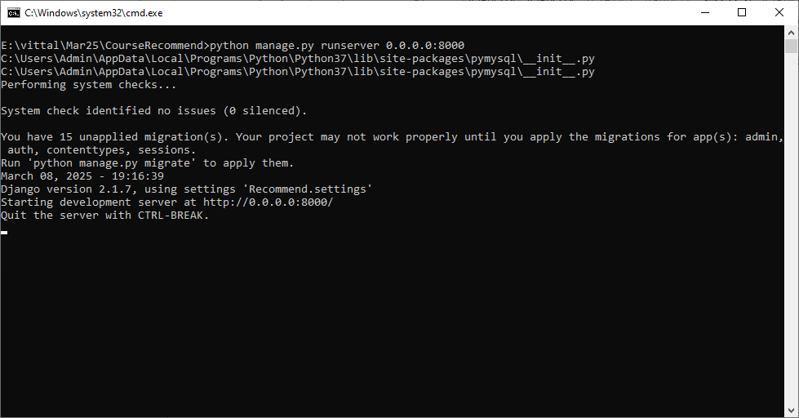
In above screen python server started and now open browser and enter URL as http://127.0.0.1:8000/index.html and then press enter key to get below page
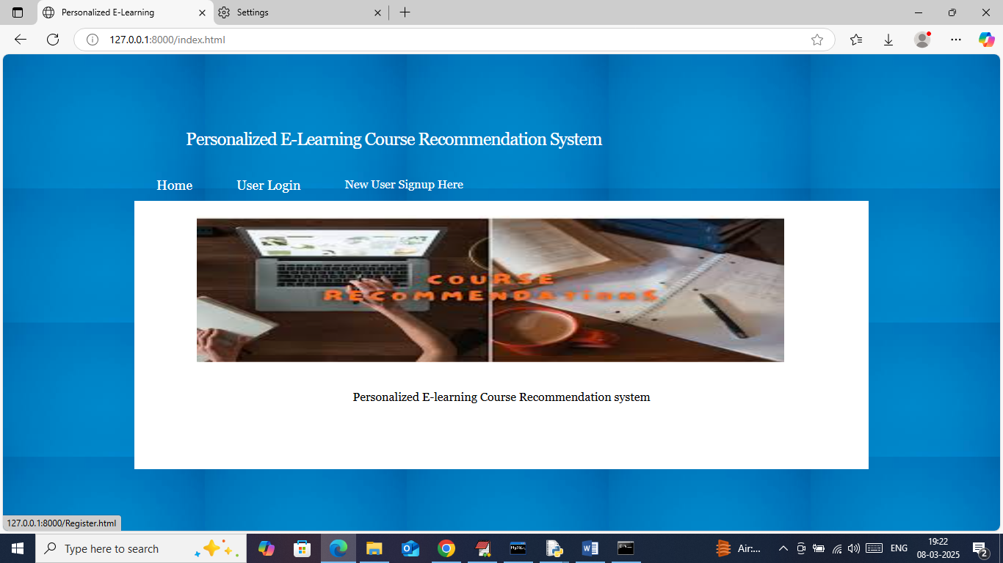
In above screen click on ‘New user Sign up’ link to get below page
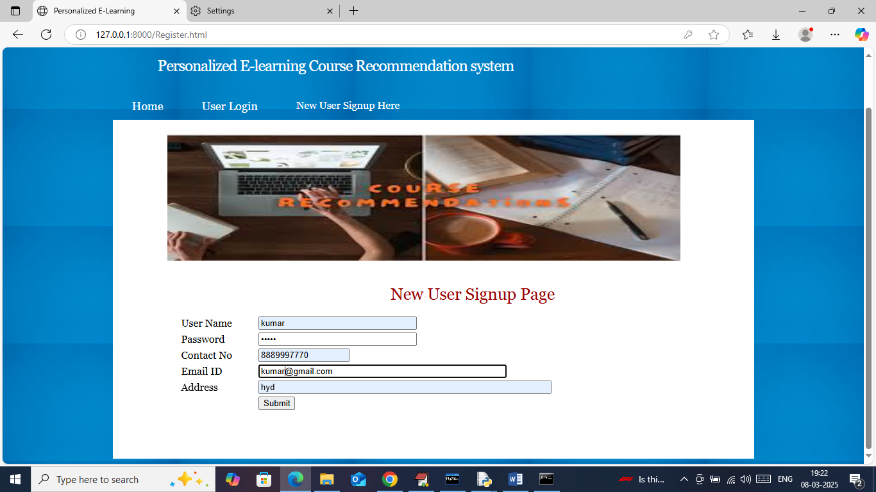
In above screen user is entering sign up details and then press button to get below page
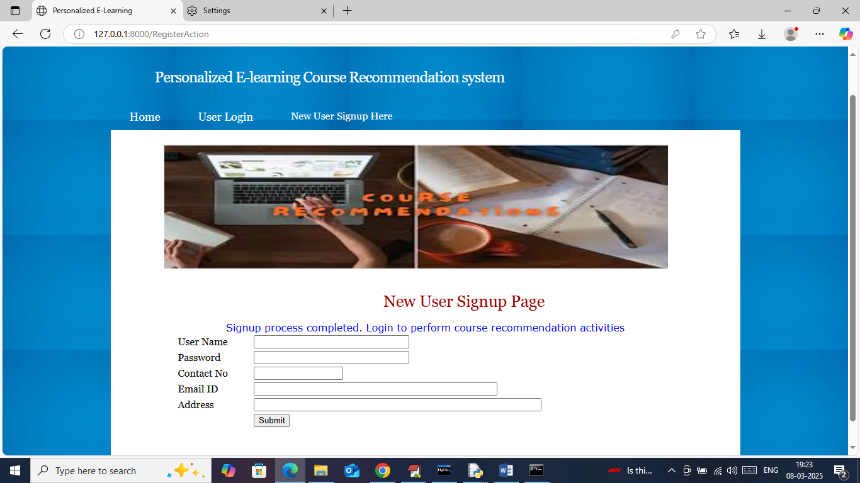
In above screen sign up process completed and now click on ‘User Login’ link to get below page
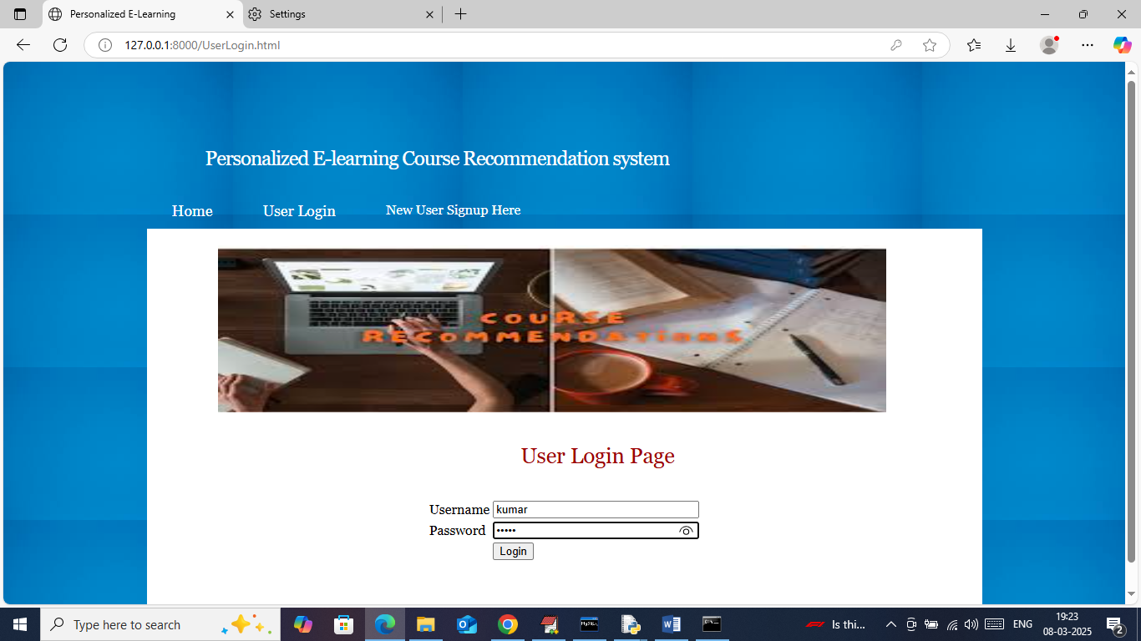
In above screen user is login and after login will get below page
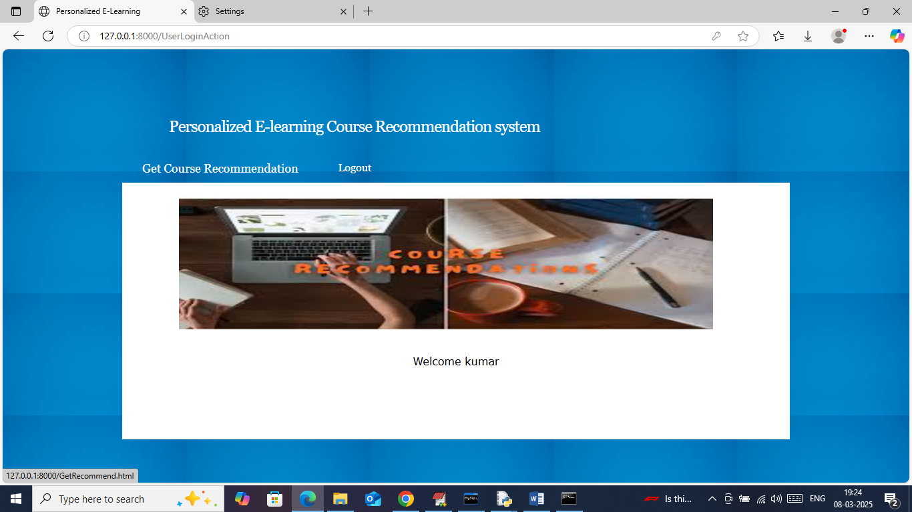
In above screen click on ‘Get Course Recommendation’ link to get below page
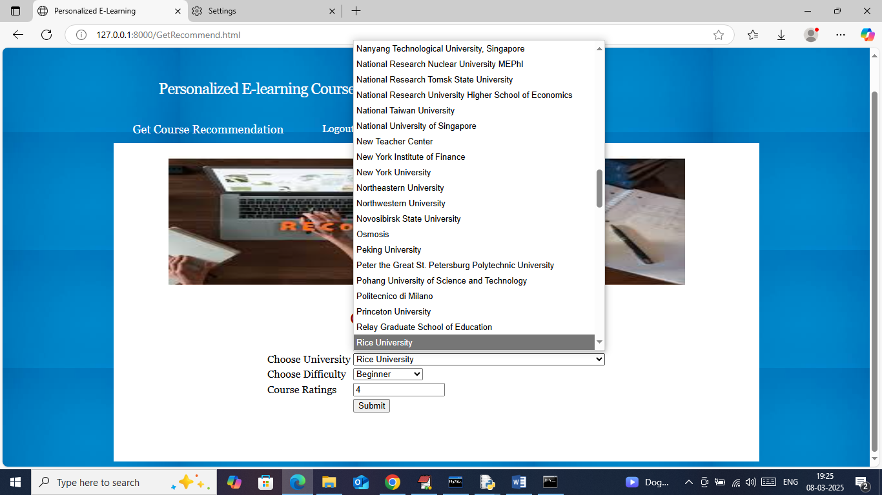
In above screen selecting desired university, difficulty level and then entering rating and then press button to get below page
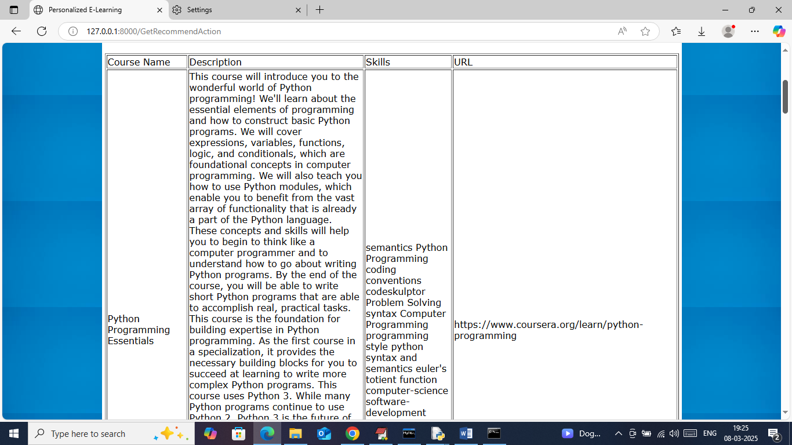
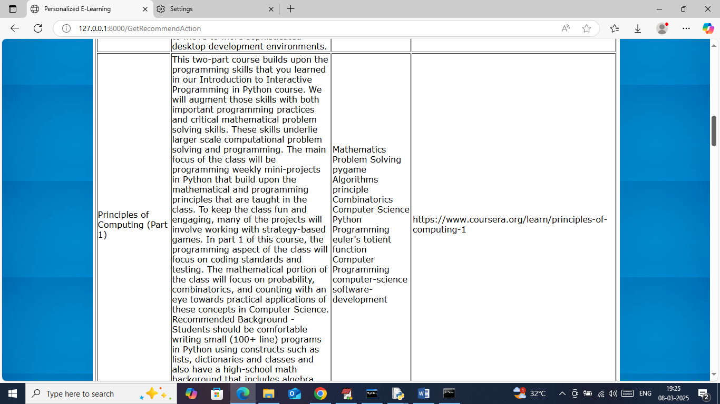
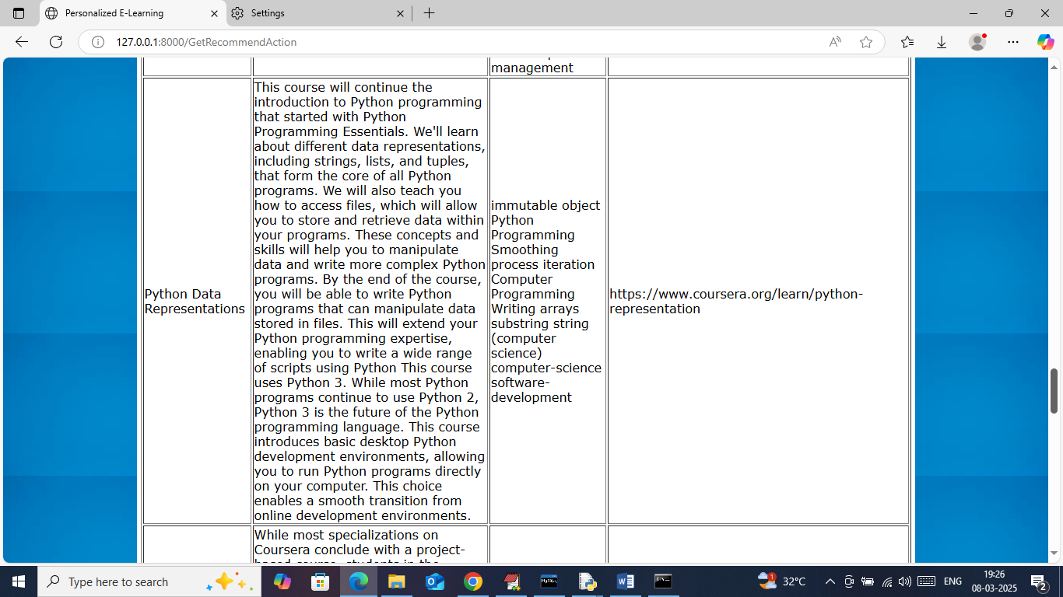
In above screen can see various number of recommendations along with course name, descriptions and skills. Similarly you can enter any values and get recommendation.
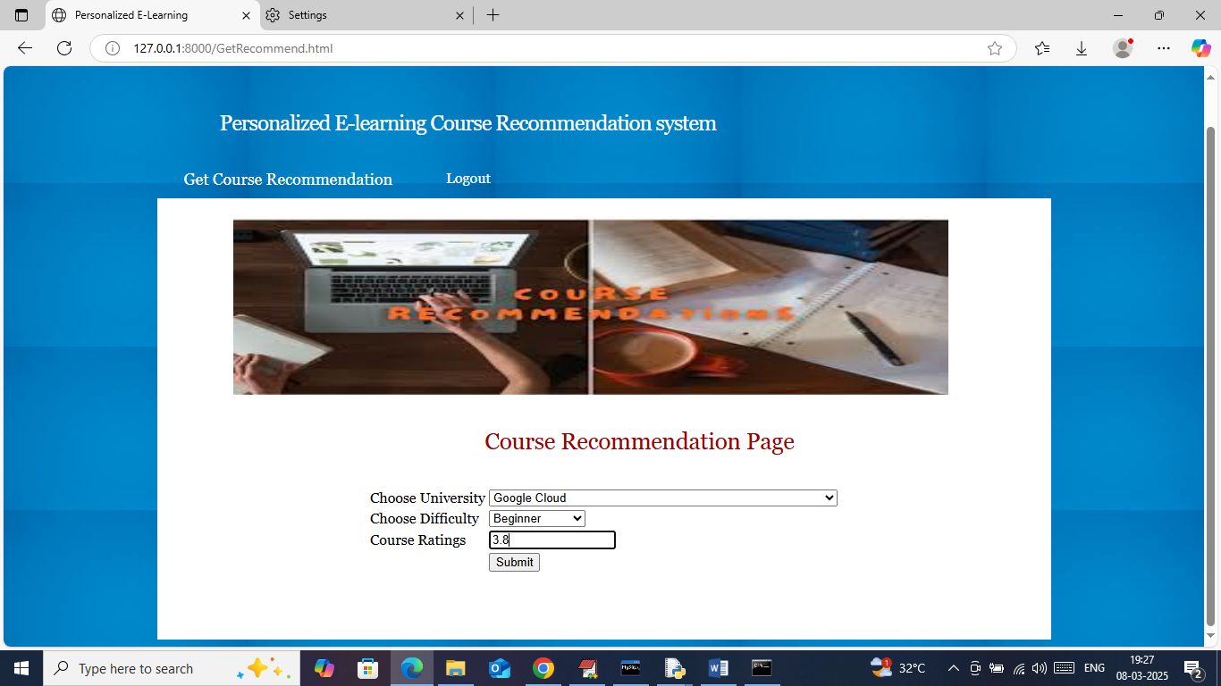
In above screen selecting another input parameters and below is the output
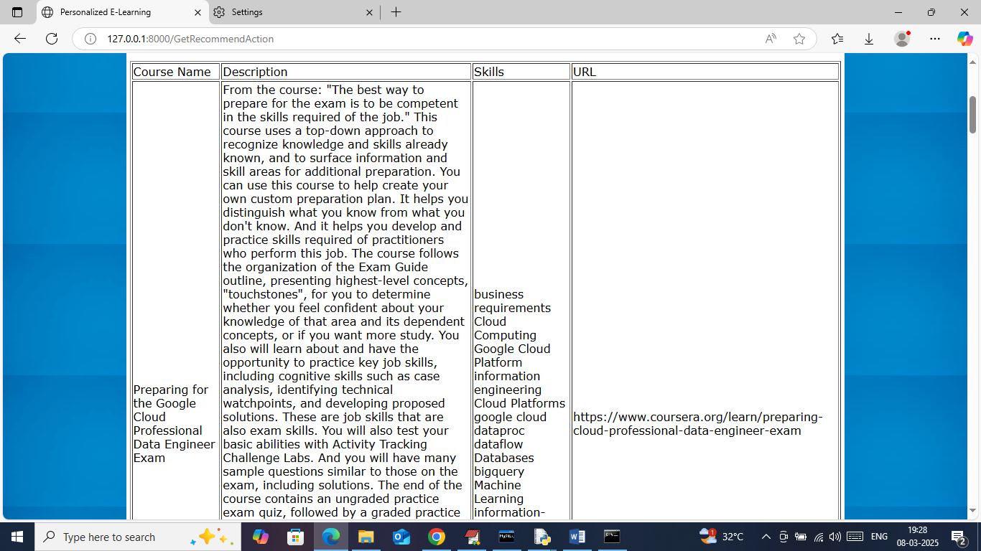
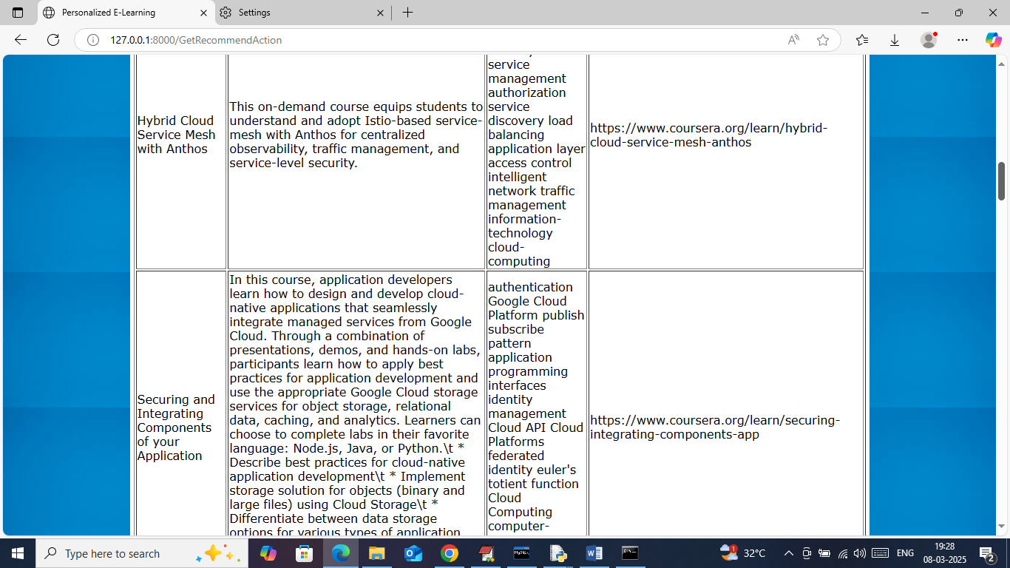
In above screen can see another recommendation.
Note: if you don’t want any column from above output we can remove them.

